III. SUMMURY OF RESULTS

**3.1 Calibration**

I don’t the data.

**3.2 Force Curves**

**3.3.1 Relationship between Speed and Force**

By using the same method of converting output voltage into force, the relationship between speed is shown with quadratic fitting as Figure 1 presented. The eight red circles in the figure stand for the force respectively on the data shown in the procedure part. By comparing with the lift force of CFD Estimate, the result shows the lift force in 10 m/s and 15 m/s are 0.16 N and 0.36 N, which are pretty difference from the CFD Estimate.

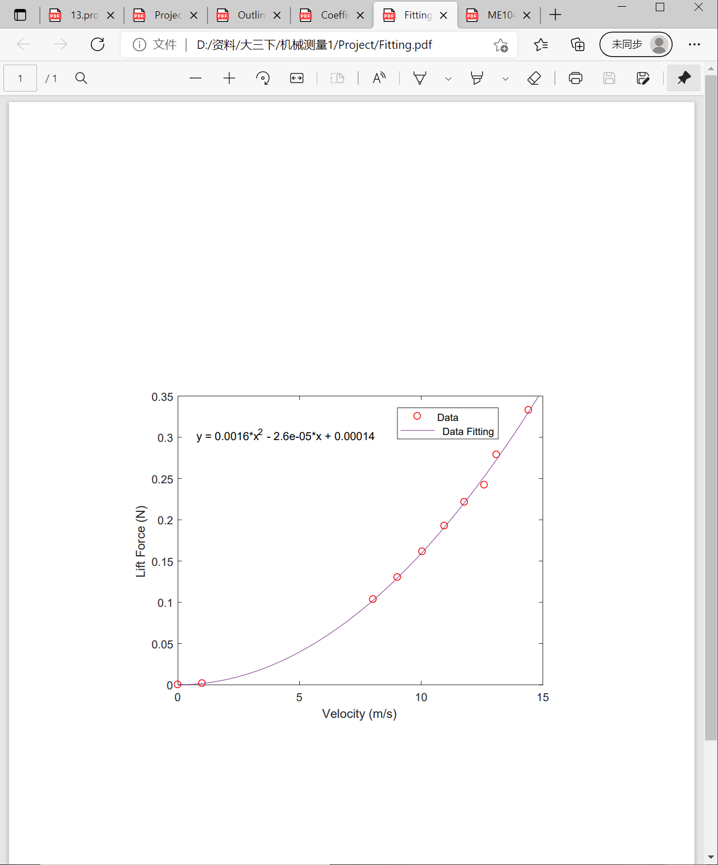

Figure 1

**3.3.2 Lift Coefficient**

By using equation (1), lift coefficient is calculated out with force in Figure 1. Assume the density of air is 1.29 kg/m^3 and he surface area equals to chord length multiply by width. By imputing the eight values of force, lift coefficient for each value and the average lift coefficient is shown in Figure 2

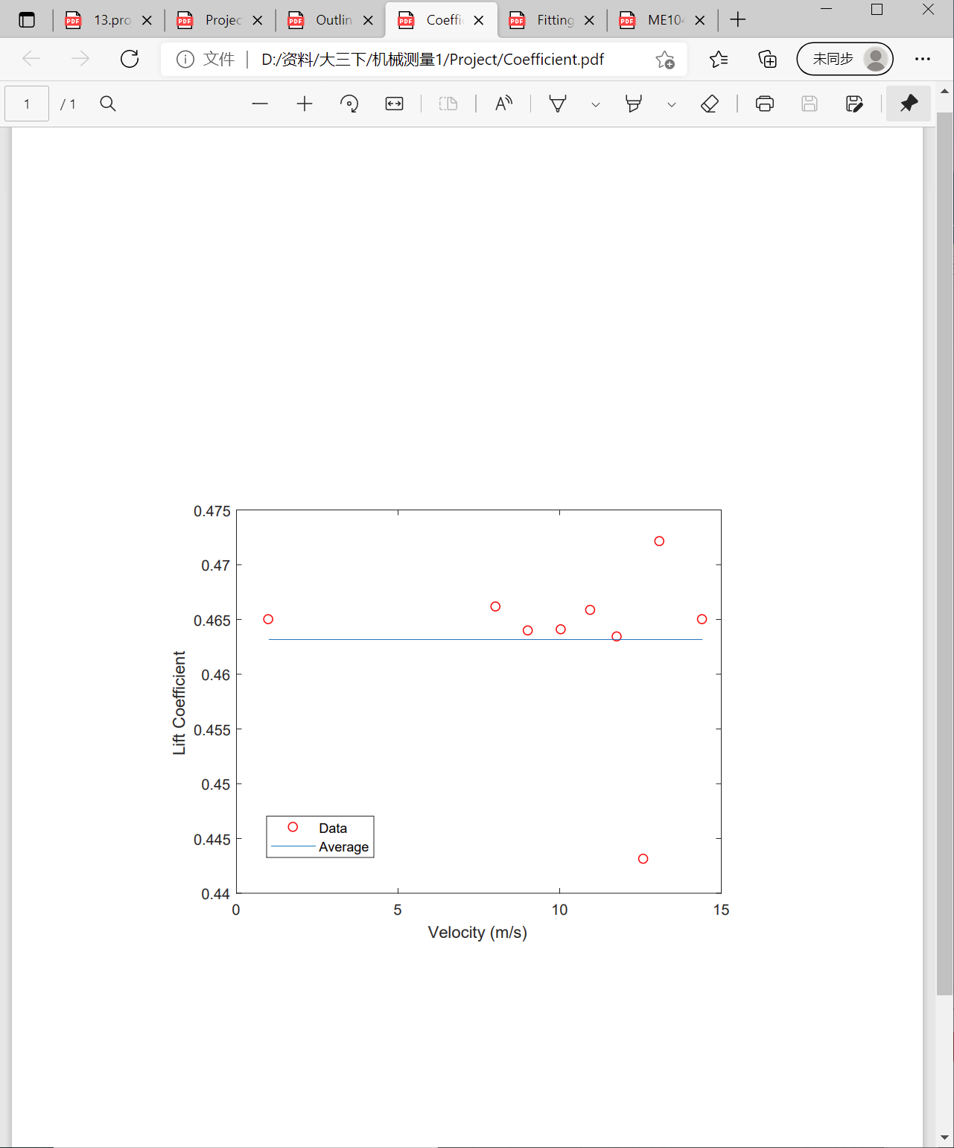

Figure 2

IV, Discussion

**4.1 Comparison to Theory**

不知道写什么。。。

**4.2 Comparison of Lift Coefficient to Simulation Results**

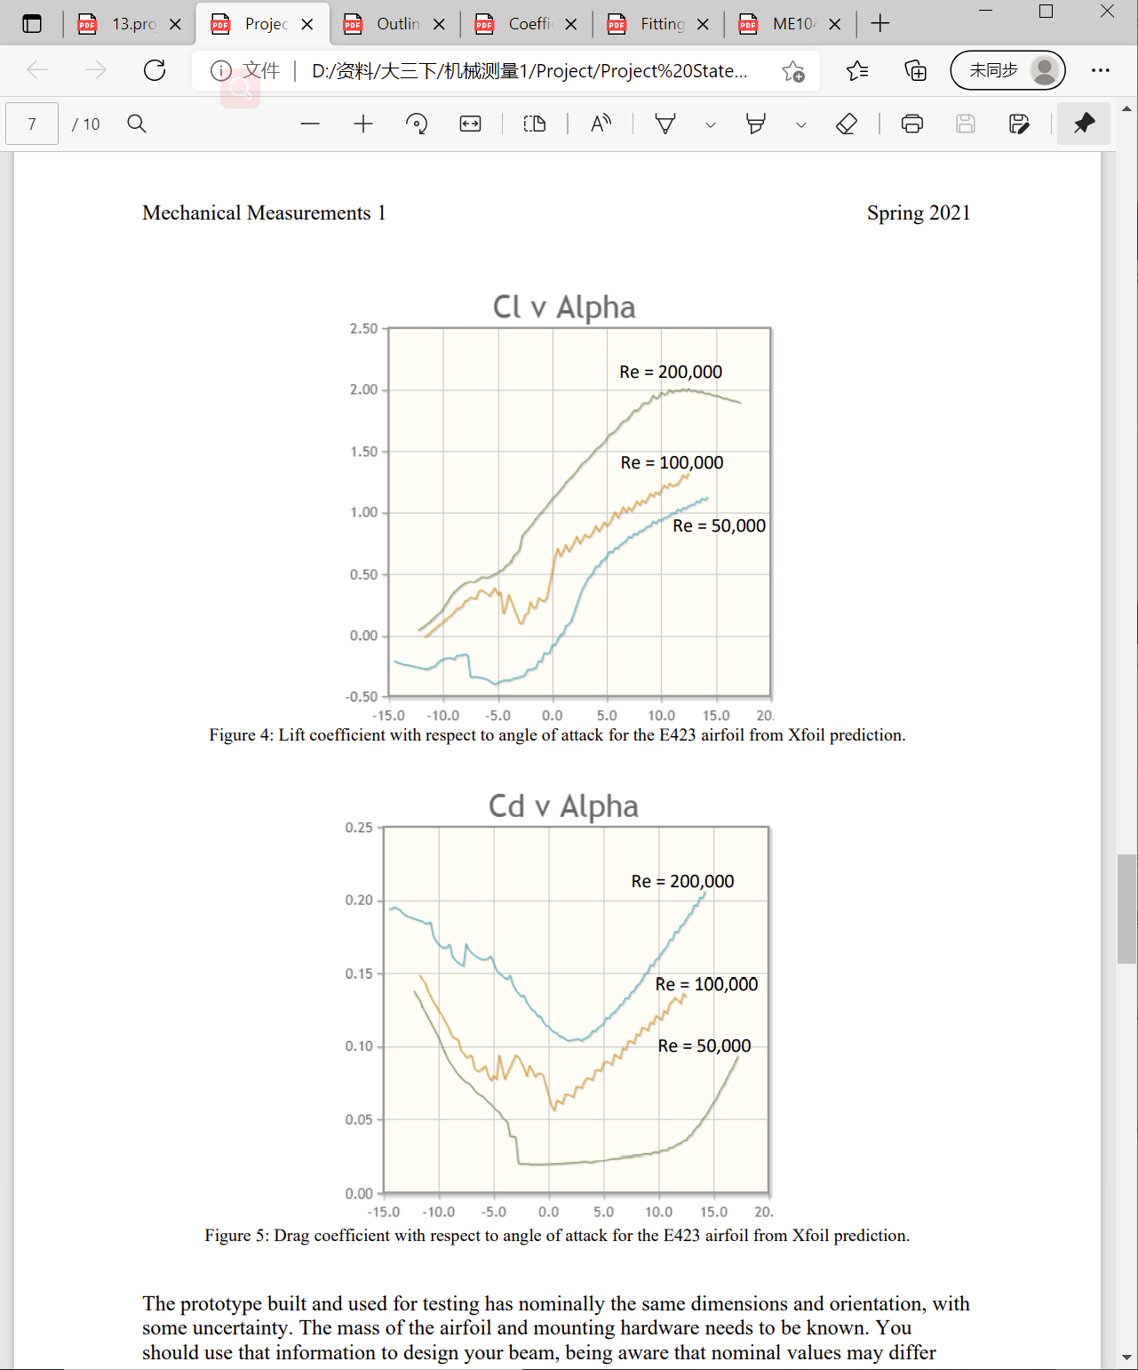

**4.3 Uncertainty Analysis**

$$u_{R}={\left[\sum_{i=1}^{L}{{\left(θ_{i}u_{{\overline{x}}_{i}}\right)}^{2}}\right]}^{\frac{1}{2}}$$

$$θ_{i}=\frac{δR}{δ{x_{i}}_{x=\overline{x}}}$$

And because

$$C_{L}=\frac{F_{L}}{\frac{1}{2}ρV^{2}A_{p}}$$

Therefore,

$$u_{c_{f}}={\left[{\left(\frac{∂C_{f}}{∂F}u_{F}\right)}^{2}+{\left(\frac{∂C_{f}}{∂ρ}u_{ρ}\right)}^{2}+{\left(\frac{∂C_{f}}{∂V}u_{V}\right)}^{2}+{\left(\frac{∂C_{f}}{∂A}u_{A}\right)}^{2}\right]}^{\frac{1}{2}}$$